* 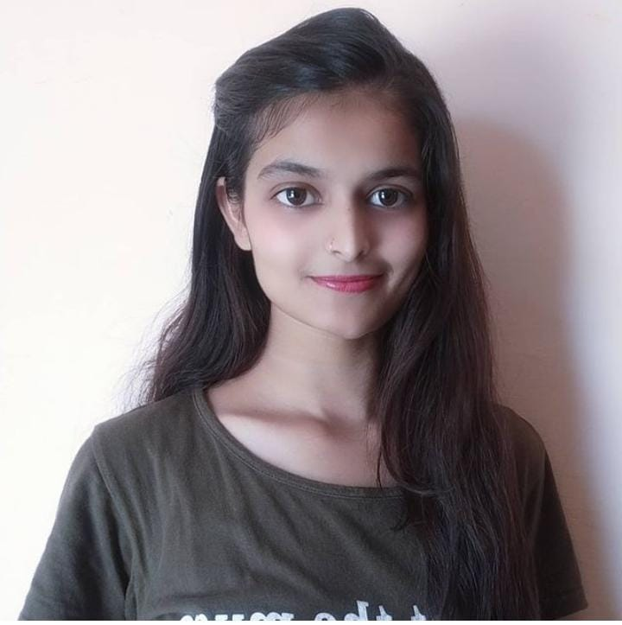 i

**ACHIEVEMENTS**

**DIVYA GAUTAM**

Web Developer with a passion for web application development and success in managing development projects. Dedicated to driving innovation with the ability to follow industry and technology trends , and facilitating early adoption of innovations.

**EDUCATION**

 <https://www.linkedin.com/in/divya-gautam-b45194210>

 https://github.com/Divya-gautam

**** [divyagautam224@gmail.com](mailto:divyagautam224@gmail.com)

 9119740089

 Nagla Brahmam , Gutahara , Sahpau , Sadabad , Hathras

**CONTACT**

FULL STACK DEVELOPER

* REALTIME CHAT WEB APPLICATION
* CENTRALIZED-GRIEVANCE-SYSTEM PORTAL
* TICKET FOR TOURISM WEB APPLICATION

***2017–2020 HIGHSCHOOL/INTERMEDIATE***

NALANDA INTER COLLEGE, VASDATTA, SADABAD , HATHRAS

***2020-2024 B.TECH ( COMPUTER SCIENCE WITH DATA SCIENCE SPECIALIZATION)***

ABES INSTITUTE OF TECHNOLLOGY, GHAZIABAD

* SIH 2022 FINALIST
* SUCCESSFULLY COMPLETED HACKTOBERFEST 2022

C++ ••••••••••••

PYTHON ••••••••••••

HTML5 ••••••••••••

CSS3 ••••••••••••

REACT ••••••••••••

NODE JS ••••••••••••

**PROJECTS**

**SKILLS**

**ENGLISH**

**• • • • • • • • • • • • • • • HINDI**

**• • • • • • • • • • • • • • • •**

n

**LANGUAGES**